**Pay Per LLC Booking Functionality**

**For Employee:**

1. Login using employee given credential

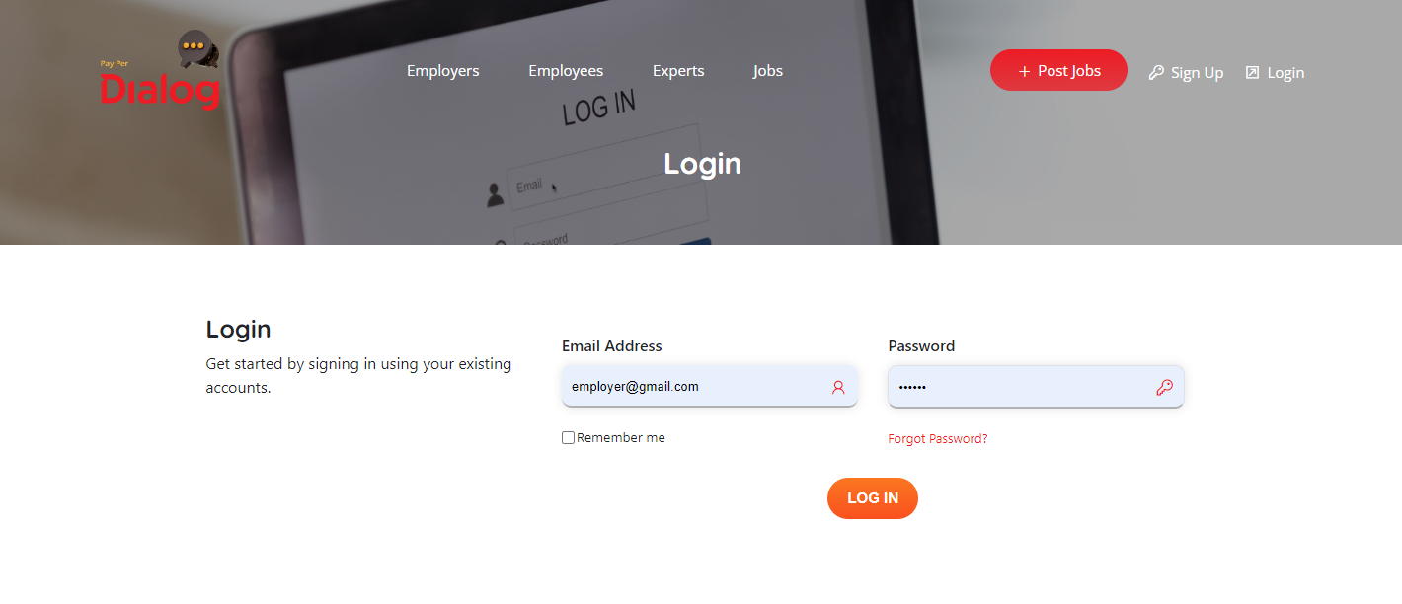

1. Click on the **Availability** tab:

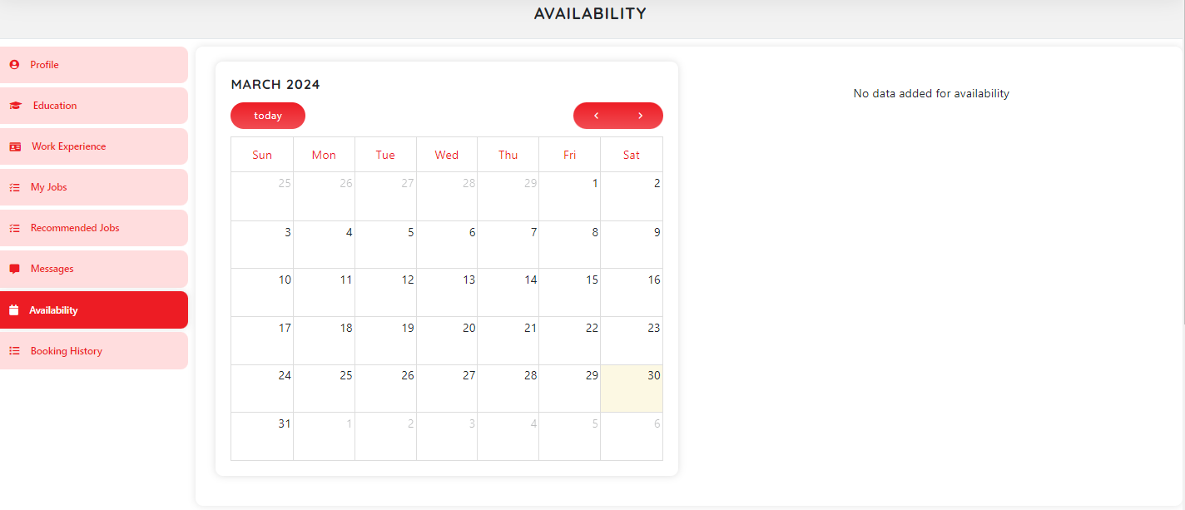

1. Click on any date from calendar, user will get a popup to add availability. User can add multiple availability at a time.

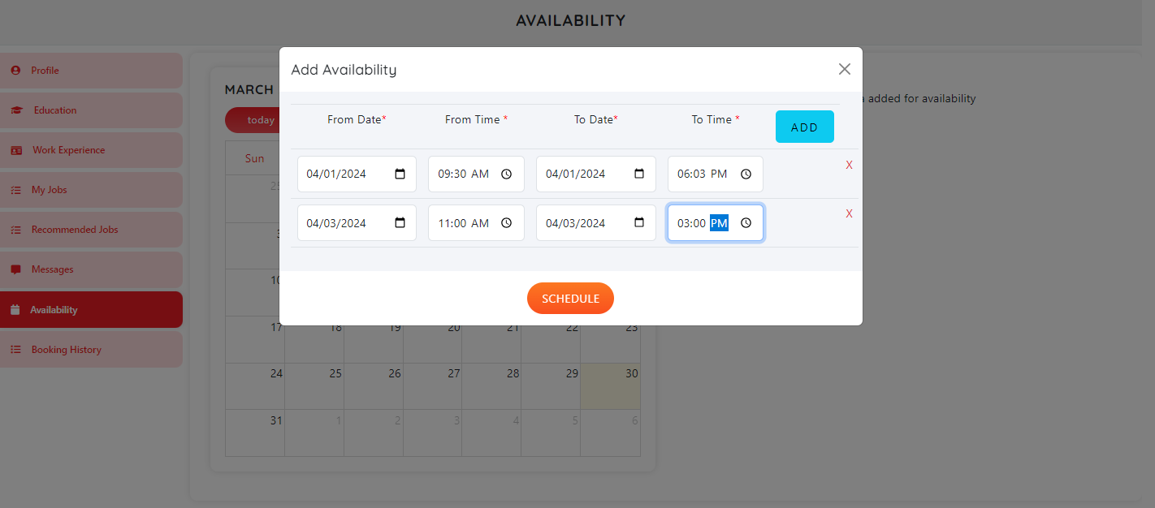

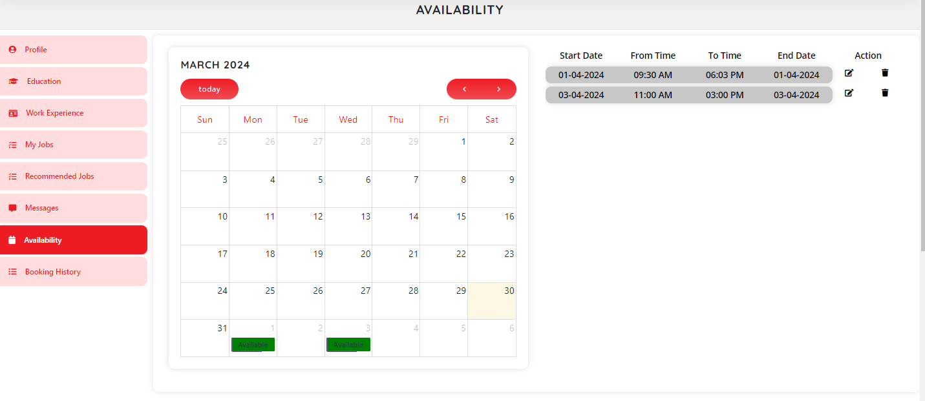

1. User can edit the availability time. Once employer book a slot for a user, that particular date will not be able to edit or delete that date.

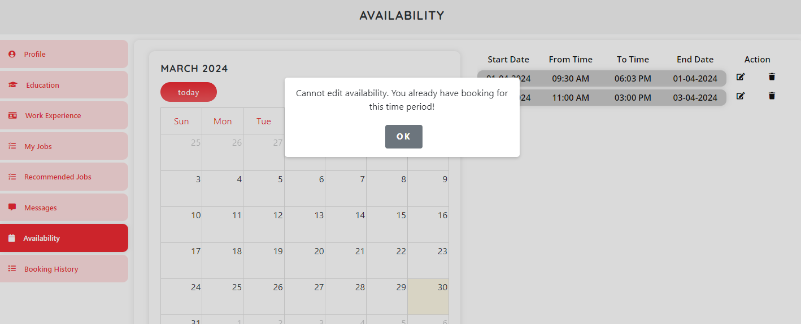

1. Above added available date and booking will show in the user profile details page.

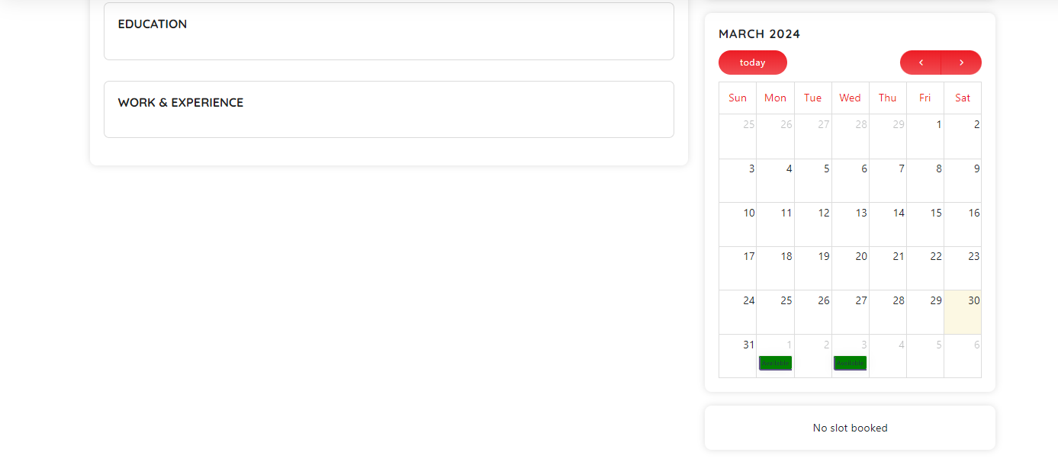

1. User can view booking list based on the calendar date on dashboard booking history tab.

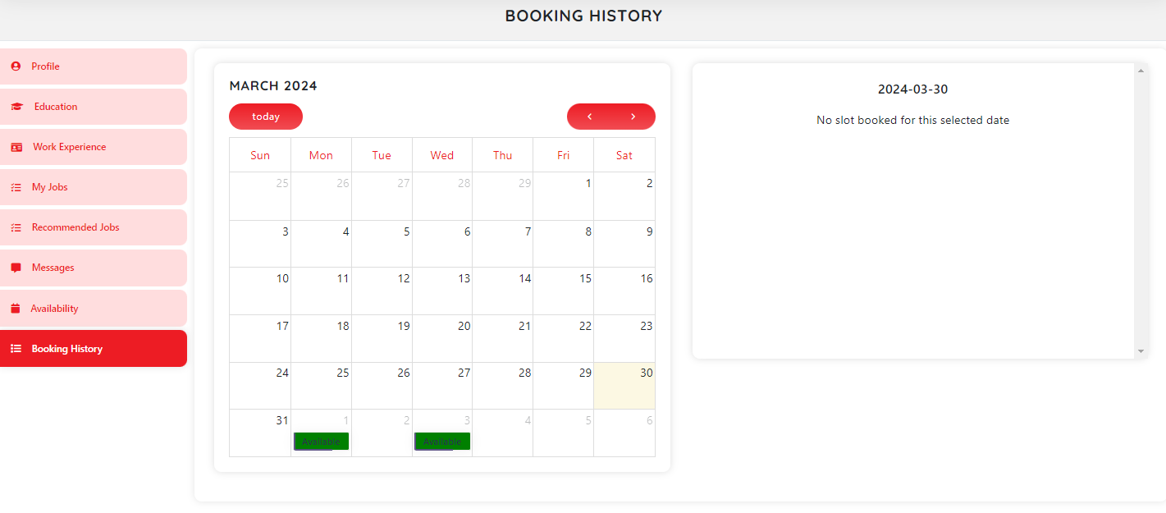

**For** **Employers:**

1. Login using employee given credential
2. Got to “Application to your Job” tab. From where employer can review and confirm bided job by the employees. Once employer change the status of job to “ready for interview”, other employees bid for the same job will be screened out status.

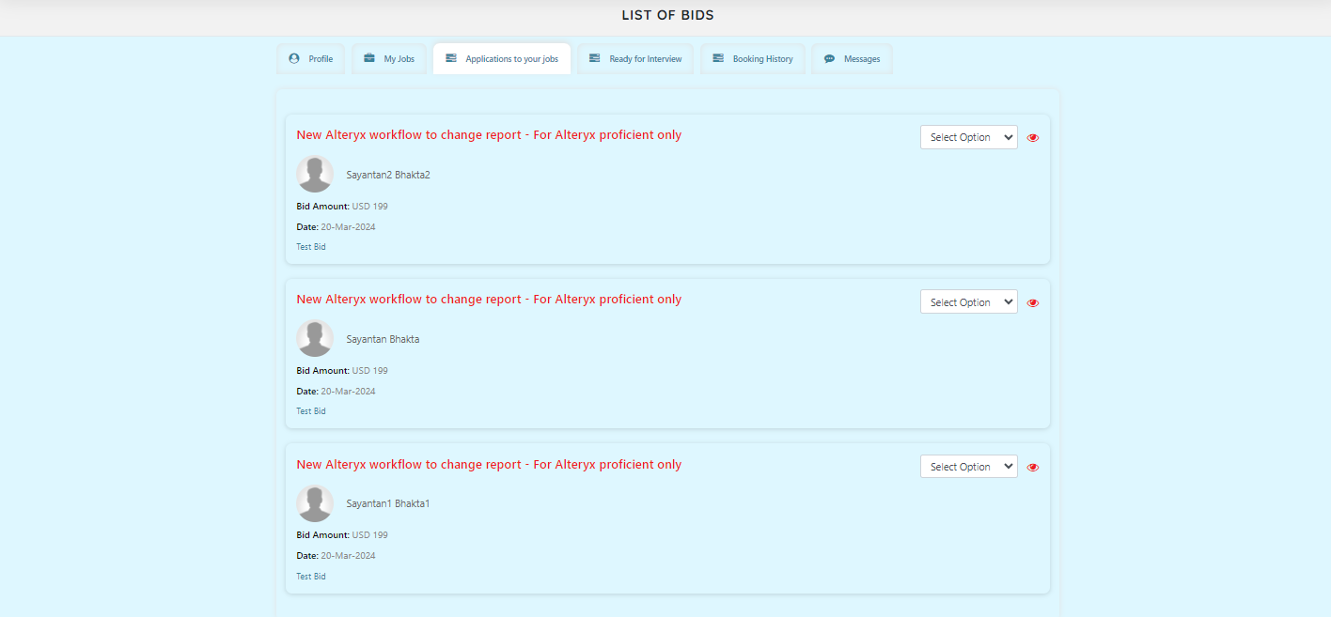

Choosing the last job bid as “Ready for interview”. After that employer need to check the user agreement.

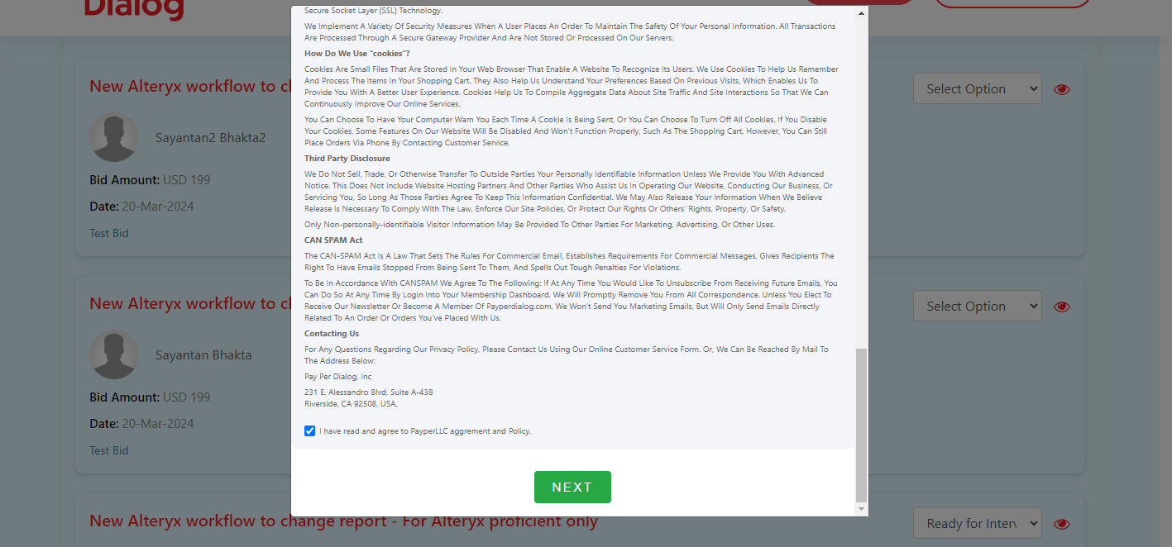

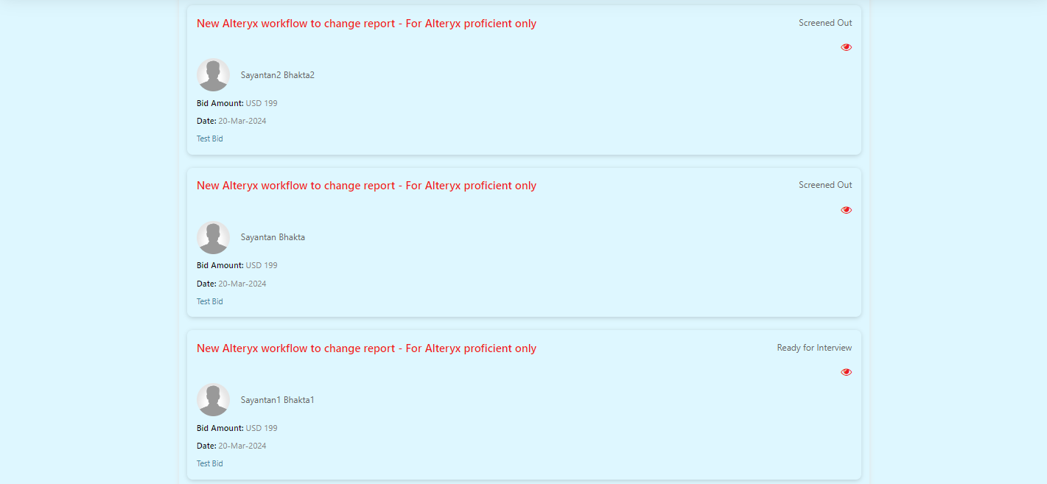

1. Once employers select a job bid to “ready for interview”, that particular employee will moved to the “Ready for Interview” tab.

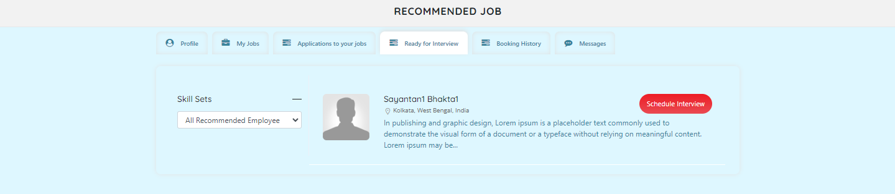

1. Click on the “Schedule Meeting” button. It will redirect to the Employee details page calendar section.

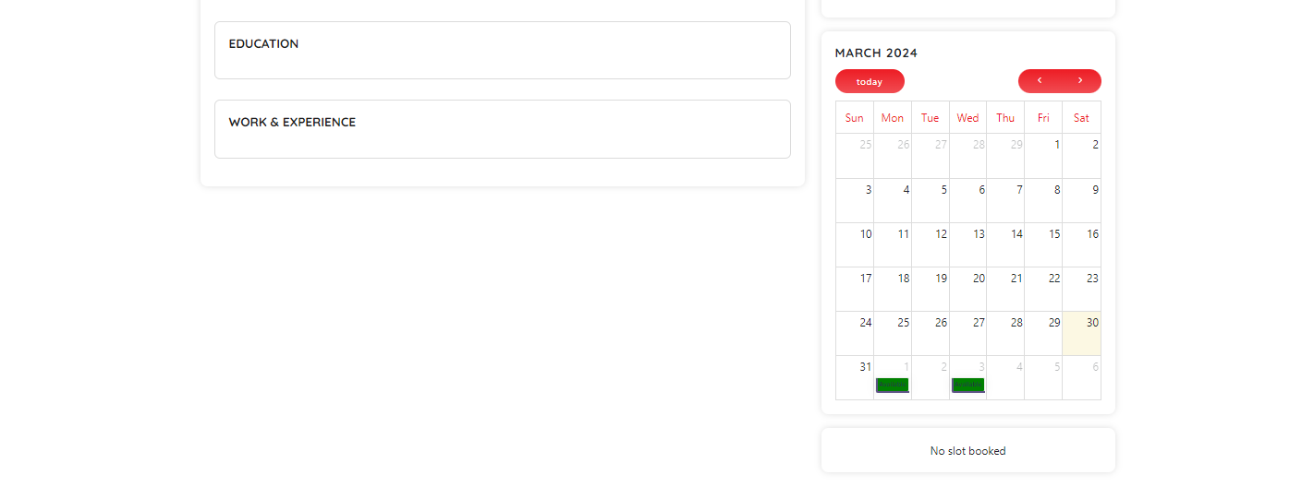

1. Click on the date to get the available time list.

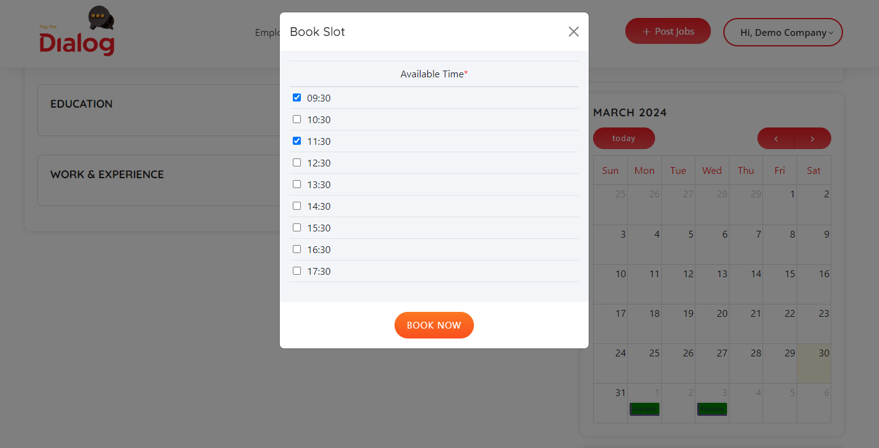

1. Click on the “Book Now” button, user need to check the agreement.

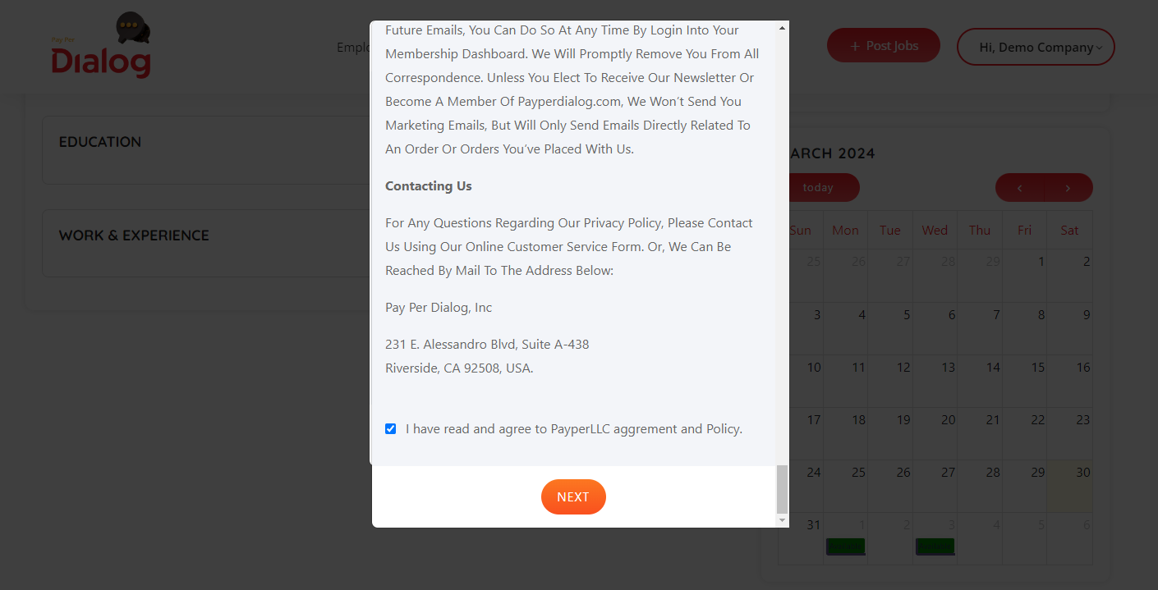

1. Click on next button employer will get a popup with check timeslot and total price.

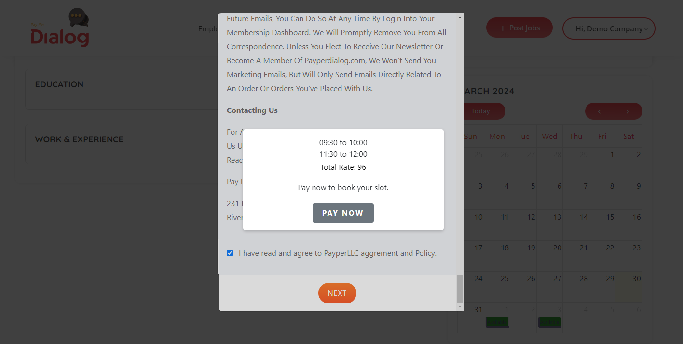

1. Click on the “Pay Now” button and wait for some time to process, get pop up for successful payment. 9.

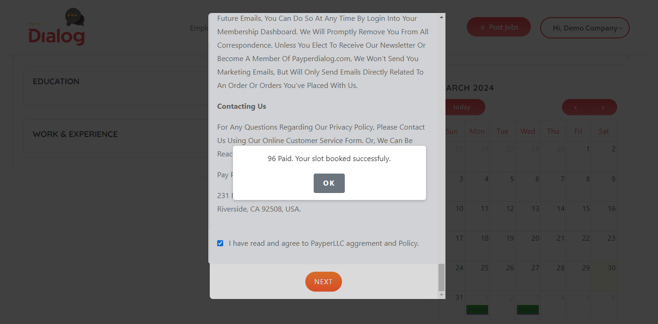

1. Click “Ok” will refresh the page and will show the booking details with zoom meeting link.

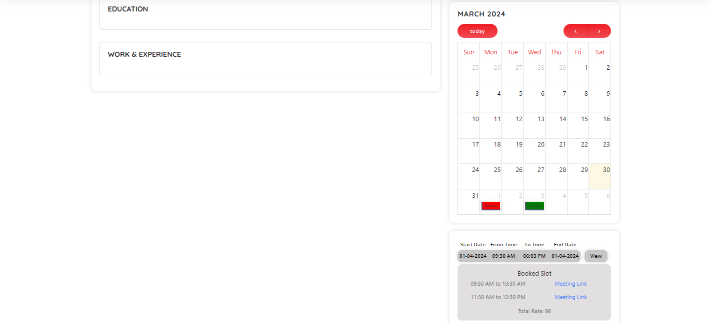

1. Same will reflect in the employer’s profile after login.

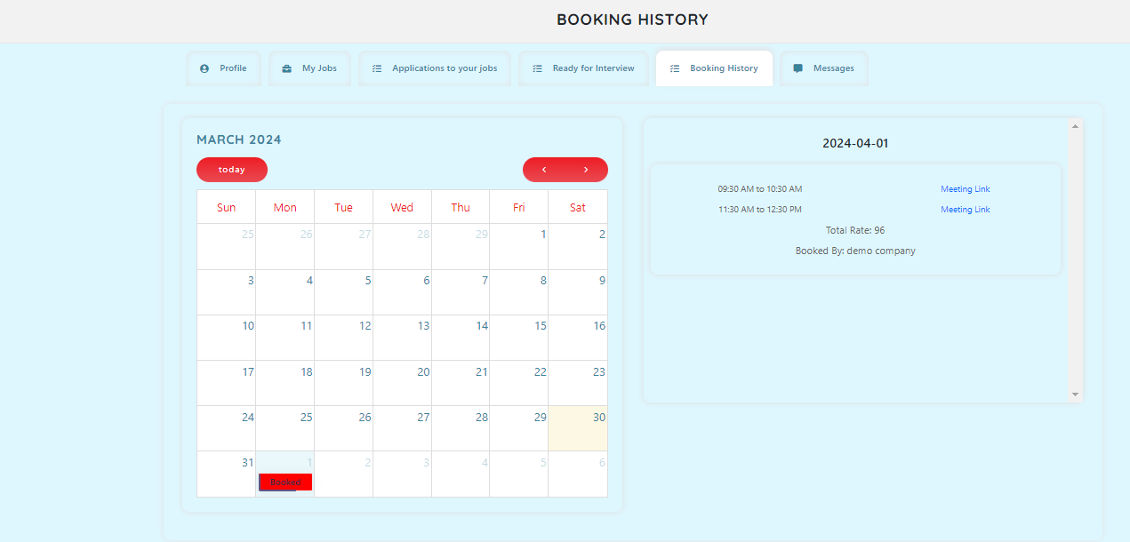

1. Same will reflect in the employee profile after login.

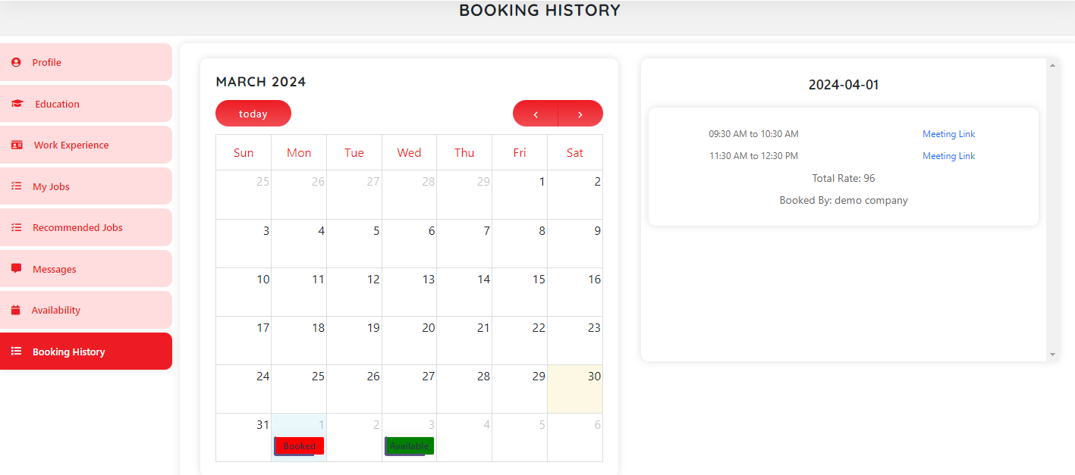

1. Click on the link user will be redirect to the Zoom meeting page.